The BeatLove
The Beatles Tribute Show
Technical rider (ENG)
Vocals:
- Four cable mics (Shure Beta 58)
- Two straight mic stands (Voc1 и Voc2), 2 boom mic stands (Voc3 и Voc4)
- 220V outlet (Voc1)

Drums:
- Professional drumset (Ludwig, Yamaha, Sonor, Tama or Pearl)
22” bass drum
12” rack tom
14” or 16” rack tom
2 cymbal stands
1 hi-hat stand
Snare drum with stand
Bass drum pedal
Drum throne
Professional cymbals set (hi-hat, crash, ride)
- Drum mic kit (Shure, Sennheiser or Audix)
- For a large concert hall drum riser is required (minimal size 2х2х0,5m)
- No drum shield is allowed

Bass guitar:
- Bass amp (Vox, Ampeg, Gallen-Krueger, Hartke or EBS)
- DI-BOX
- Jack-Jack cable
- 2 guitar stands

Guitars:
- Guitar amp (Vox AC30, Fender Twin Reverb or Deluxe) miked by Shure sm57 or Sennheiser e904, Jack-Jack cable
- Guitar amp (Vox AC30, Fender Twin Reverb or Deluxe) miked by Shure sm57 or Sennheiser e904, Jack-Jack cable
- 6 guitar stands
- DI-BOX for Acoustic guitar

Keys:
- Professional workstation or electric piano (Yamaha, Nord, Roland, Kurzweil)
- Sustain pedal
- 2 DI-BOX
- 2 Jack-Jack cables
- Keyboard stand
- Throne
- 220V outlet

Playback:
- XLR-cable to drummer
- 220V outlet

Monitors:
- 3 in-ear body packs (Sennheiser or Shure)
- Cable for drummer's in-ear (Jack-Jack)
- 5 stage monitors 12”+1,5”

Input list:

CH | INSTRUMENT | MIC/DI-box | INSERT
1 | Kick | Shure Beta 52A (Audix D6) | gate/compressor
2 | Snare | Shure SM 57A (Audix i5)
3 | Hi-hat | Shure SM 81, AKG С 451
4 | Rack tom | Sennheiser e904 (ShureBeta 98, 56) | gate/compressor
5 | Floor tom | Sennheiser e904 (ShureBeta 98, 56) | gate/compressor
6 | Overhead L | Shure SM 81, AKG С 451
7 | Overhead R | Shure SM 81, AKG С 451
8 | Play Back | XLR
9 | Bass | Active Di-box | compressor
10 | Guitar L | Shure SM 57, SENNHEISER E906
11 | Guitar R | Shure SM 57, SENNHEISER E906
13 | Keyboard 1 L | Di-box
14 | Keyboard 2 R | Di-box
15 | Voc1 | Shure Beta 58A | compressor
16 | Voc2 | Shure Beta 58A | compressor
17 | Voc3 | Shure Beta 58A | compressor
18 | Voc4 | Shure Beta 58A | compressor
18 | Acoustic Guitar | Di-box

Stage plan:
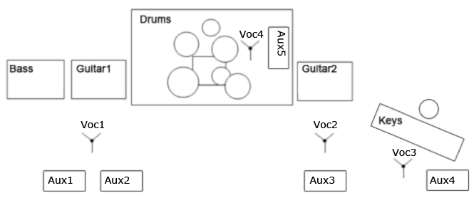
If you got any questions please mail me: sergey@beatlove.net

